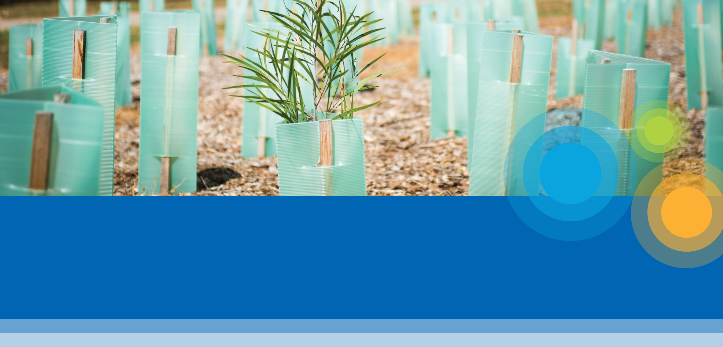
Planting Near Sewers, Drains
and Water Mains Guide
October 2022

Key points
Inappropriate planting near Melbourne Water
assets can:
• Damage buildings and block pipes
• Increase flood levels
• Cause critical water supply failures
• Damage levee and retarding basin embankments
• Block maintenance and emergency access
Melbourne Water seeks to balance asset protection and maintenance with the natural environment, aesthetics and biodiversity.
Melbourne Water has classified vegetation types into four categories reflecting their general growth habits and thus their suitability for planting near Melbourne Water assets.
About this guide
This guide provides general information for proposed plantings near Melbourne Water’s utility installations only. The information contained herein does not constitute consent, nor does it preclude the need to obtain relevant approvals under other legislations, such as under the Special Building Overlay or Land Subject to Inundation Overlay.
Melbourne Water consent is required before any excavation or planting occurs.
Quick Tip
For information on underground assets, please
contact Before You Dig www.byda.com.au

Melbourne Water’s critical infrastructure, such as water supply, sewerage and drainage structures, can be damaged by inappropriate planting.
Trees and shrubs are an important part of the urban and rural environment. They contribute to local amenity, urban cooling, increased biodiversity, habitat, air and water quality and soil stability. Unfortunately, trees and shrubs are not always compatible with critical infrastructure such as buildings or underground services such as sewers, drains or water supply pipes.
Drains, sewers and water mains can become blocked and damaged by tree roots, disrupting services to the community and involving costly repairs. Tree roots can damage external protective coatings on pipelines leading to accelerated corrosion and early failure. Vegetation can block access to critical maintenance points, such as maintenance holes and vent pipes.
Inappropriate landscaping along drains or floodways can obstruct flow resulting in increased flood levels. Trees can also weaken levee banks and dam walls, potentially causing the bank to leak or collapse.
Melbourne Water has produced this guide to assist in choosing the appropriate planting location for trees, shrubs and grasses to help reduce potential damage and flood risk.

October 2022

Where does this guide apply?
This guide gives advice on the types of planting which may be appropriate near underground pipes (such as drains, water mains or sewers), associated structures (e.g. vents, valves, cabinets and manholes), floodways, flood plains, retarding basins and levee banks. Please note that not all structure types have been listed.
Melbourne Water’s consent is required where vegetation will encroach within an easement or Melbourne Water owned land; within 5 meters of an asset (from the outside edge of asset) or 20 meters from a waterway (from the top of bank), regardless of land ownership.
Diagram 1: Floodway within overland flow path
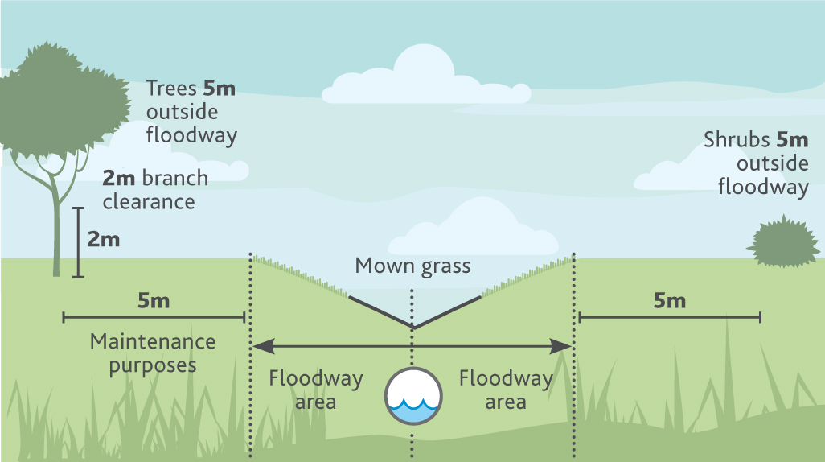
Diagram 2: Underground pipes and associated infrastructure (e.g. manholes and vent stacks)
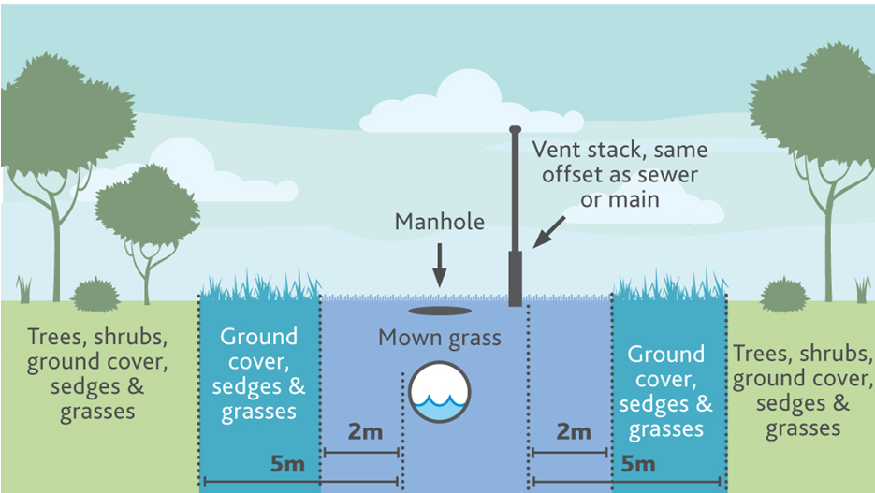
Diagram 3: Levee bank
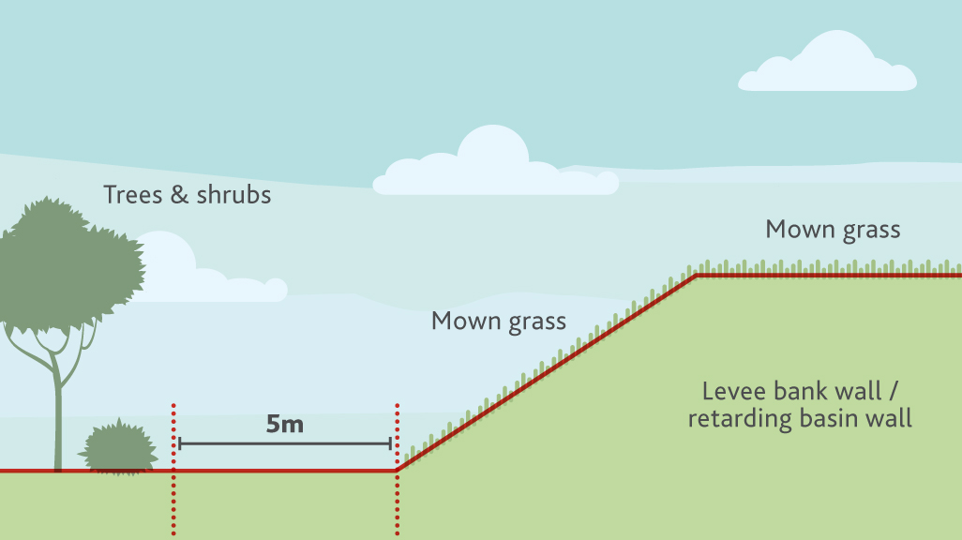

Vegetation types
Diagrams 1 to 3 show minimum offset distances for each vegetation type:
• Mown Grass: up to 30cm in height
• Ground cover/Sedges: up to 1.5m in height
• Shrubs: 1.5m–4m high
• Trees: 4m and above
Vegetation should be planted in such a way to account for future growth. This ensures the roots and canopy of the mature vegetation remain outside the offset area. When choosing an appropriate species and planting location it is important to consider the typical growth habits of the species and its suitability to the site. The form of vegetation is generally indicative of its root system, however, some species may have particularly vigorous root systems. For more information regarding suitable species please contact your local Council or nursery.
Additional protection: Root Barriers
In addition to the required offset distances, Melbourne Water recommends the use of root barriers. Correctly installed root barriers can help prevent or limit the impact of tree roots on surrounding infrastructure by reducing root growth beyond the barrier or diverting root growth away from the barrier. Please contact your local nursery for product and installation advice.
Other Approvals
Tree planting and associated activities may need to comply with other regulations or legislation not administered by Melbourne Water, e.g. Special Building Overlay or Land Subject to Inundation Overlay.
Who do I contact?
Please contact Melbourne Water – Asset Services for further information regarding planting and landscaping structure requirements, build-over agreements and conditions.
Applications can be completed online at our website www.melbournewater.com.au
Email: asset.services@melbournewater.com.au
Website: www.melbournewater.com.au
General Melbourne Water Enquiries 131 722
Asset Services Enquiries 131 722

